Diffrence b/w Interface and abstract class->

|  |  |  |
| --- | --- | --- |
|  | Interfaces | Abstract class |
| 1 | 1.if we don’t know the about the implementaion and know about the requirement | 1.if we know implementation then we goto abstract class. |
|  | 2.its known as 100% pure abstract class .every method is public and abstract.wheter we define or not. | 2.we can write a concrete and abstract class.its 0 to 100% abstraction . |
|  | 3.we cant declare the interface method with the following modifiers.>public and abstract only,private,protected,  ->final, static, | 3.there is no restriction of abstract class. |
|  | 4. variable is also public static final. | Is simply public. |
|  | 5. Abstract class **doesn't support multiple inheritance**. | Interface class **does support multiple inheritance**. |

Interface we can’t define method in that and in abstraction class we cant define.

Interface ka usage bht h ad isko class implement krti h pura. Iski subclass me utni hi method run hogi jitni iske interface me define h;

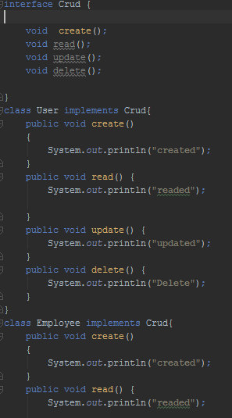 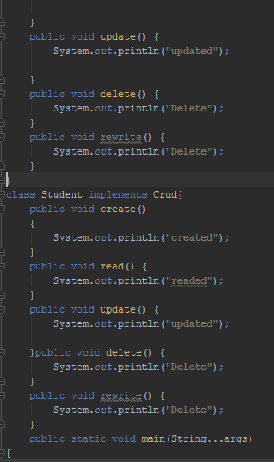 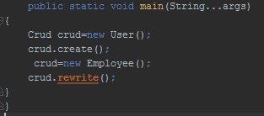

Isme jo rewrite h jo employee me define h wo call ni hogi kuki wo interface me define ni h..